VIRTUAL FAIRS 2020

Information for Students, Parents & Counsellors

HERE’S HOW TO PARTICIPATE IN OUR FAIRS.

STEP ONE – REGISTER: https://postsecondarybcvirtualfair.easyvirtualfair.com/prefair/
https://postsecondarybcvirtualfair.easyvirtualfair.com

You will need to complete the registration form and set your own password, which will be good for the rest of the year while the fair is online. The first link is for those wishing to pre-register.

STEP TWO – LOG IN TO YOUR LIVE EVENT: Go to the same URL and log in with your email and password. If you have not pre-registered, do this first before you log in on the day of your event.

ONCE YOU ARE IN THE ONLINE FAIR: There are 25+ different ‘booths’ that you can visit. Some will be doing live presentations during events: CHECK WITH THE BOOTHS you are most interested in to see if/when they are doing a live presentation, so you can plan to get the most out of the 6-hour live event. For a complete list of the scheduled presentations being offered by each institution, please refer to the menu on the left-hand side under ‘Webcasts Agenda’.

Visit all the other booths, especially those you might not be familiar with, to see what information they have that you can view [pre-recorded videos] and documents you can download.

COMMUNITY FAIRS: In addition to our dedicated high school weeks, the Strengthening Connections Virtual Fairs will be live and open to everyone. Check out the dates and times on the Strengthening Connections website.

IN ADVANCE OF YOUR VIRTUAL FAIR: learn more about all of the Strengthening Connections member institutions by checking out our website: www.strengtheningconnections.ca
KEY POINTS

REGISTER: You must complete the registration form to access the Strengthening Connections virtual fair.

DEDICATED WEEKS BY REGION: We ask students, parents and Counsellors to take in the fair during the week we have dedicated to their region, so that we don’t have an overload online.

SIX-HOUR EVENTS: Each Strengthening Connections fair is a 6-hour live event, which you can enter at any time. When you login in you are redirected to the Fair Entrance. To Enter – CHOOSE PAVILLION B

LIVE PRESENTATIONS: Live presentations will take place at some of the booths; some members may be live more than once throughout the day. Some may not choose to do a live presentation but might be available for live conversations. Check the booth of the institutions you are interested in to see when they might be doing a live event.

ONLINE CHATS: Most institutions will be live with an online chat, so you can ask your questions direction to a person.

EXPLORE WHAT EACH MEMBER INSTITUTION HAS TO OFFER – THIS IS WHAT IT WILL LOOK LIKE:

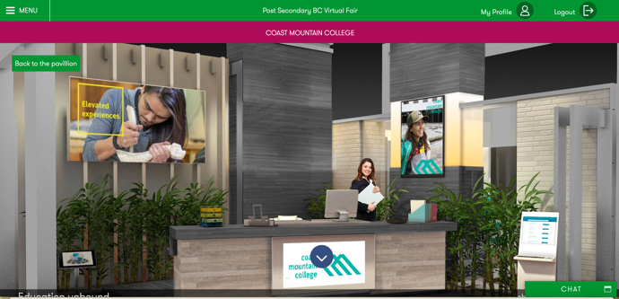
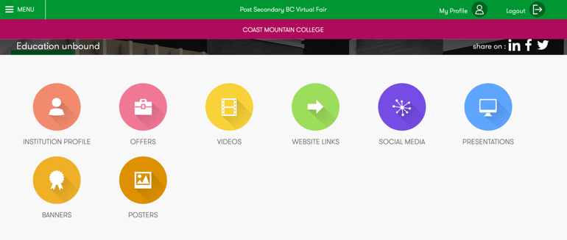

BETWEEN EVENTS: You can log in to look at pre-recorded information and download materials from all booths at any time when there is no live event taking place.

